

FakeNewsDetectionusingNLP

PHASEIVPROJECTSUBMISSION

Arava Jyothish

720921104013

# ProblemStatement:

Beginbuildingthefakenewsdetectionmodelbyloadingandpreprocessing the dataset. Load the fake news dataset andpreprocessthe textualdata.

# DataCleaning:



Datacleaningisaprocessofremovinginconsistenciesinthedatasetandincorrectvalues.Italsoininvolveshandlingmissingvalues

eitherbyremovingthemorassigningthemaveragevalues.Ithelpstoimprovetheefficiencyofthemodel.

Inthefirststep,wewillonlyremovetheunnecessarydatapointsfrom the dataset which does not helps in improving the modelperformance.

Initiallyweimportthenecessarypackagesforourdatacleaningprocessand also inthefuture purposes,

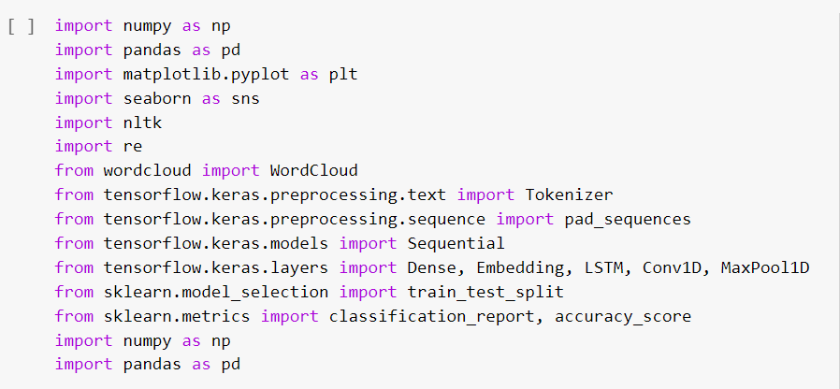

weusethesepackagesinvariousstagesofourcleaningprocessandalsoin thefutureinwhichwe needtobuildmodels.

Here,wereadthe.csvfilesoftrueandfakenewsandthenexplorethecountvaluesof their subjects

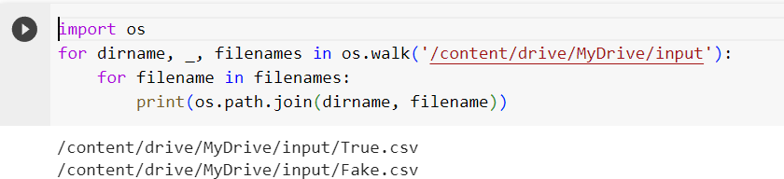

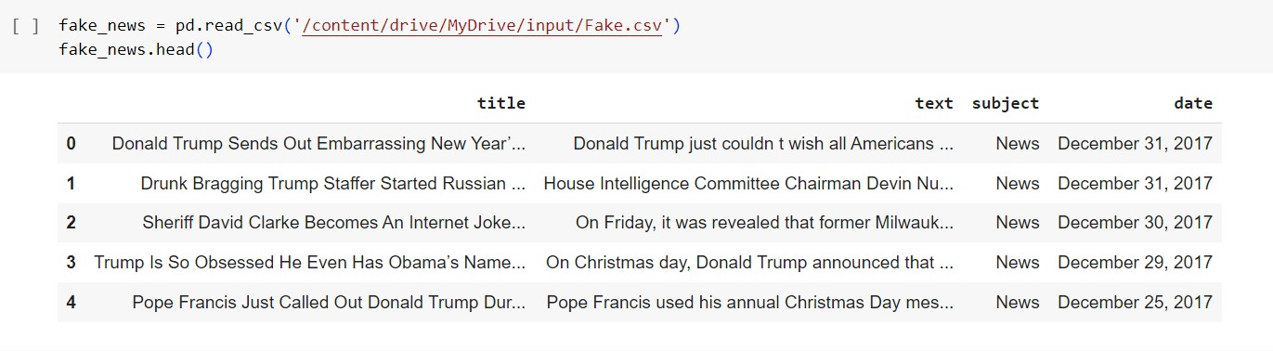

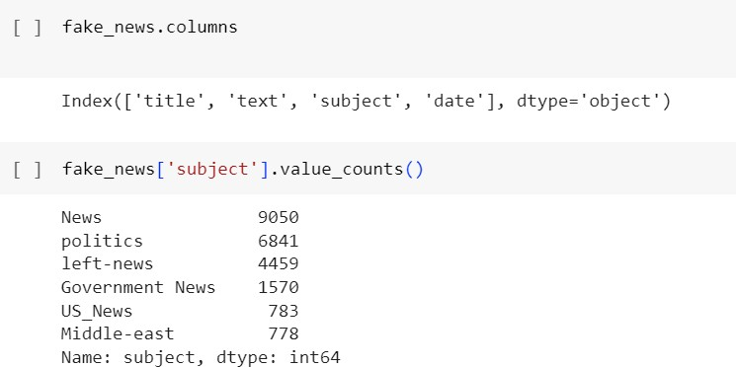

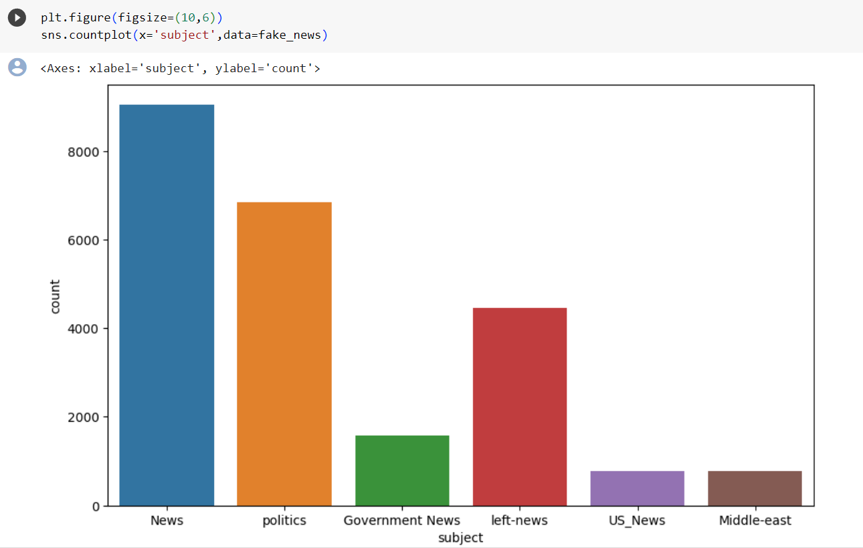

Here,wehaveusedwordcloudtoseethatwhichwordhasmostlyused for the fake news. By seeing that we can make a conclusionthatwhichtopic(aboutaperson,eventoranything)ismostly

containsfakenews).Wealsodothesamefortruenews.

# WordCloudforFakeNews:

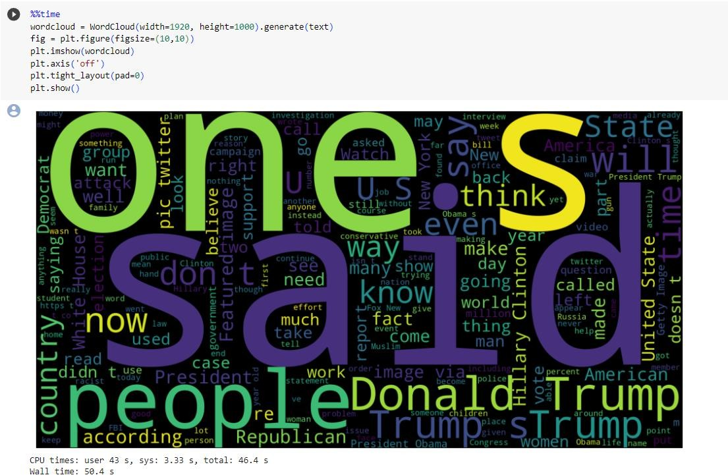

WordcloudforTrueNews:

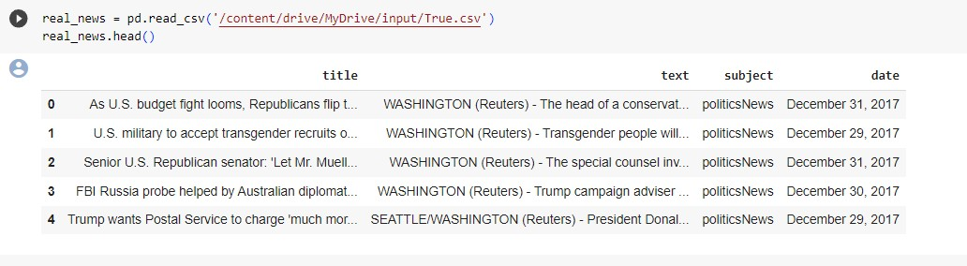

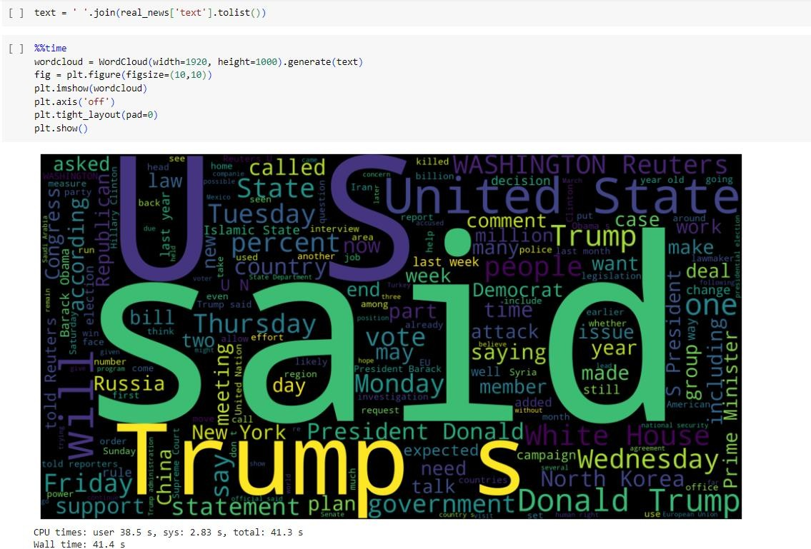

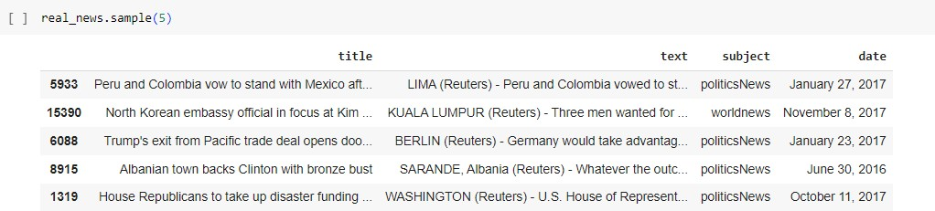

Let’screatealistofnewslistsinreal_news.csvwithunknownpublishersbyusingthefollowingcodesnippets

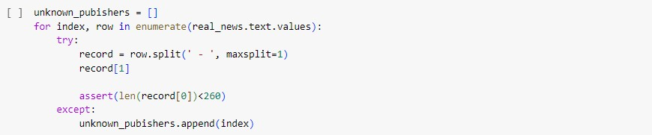

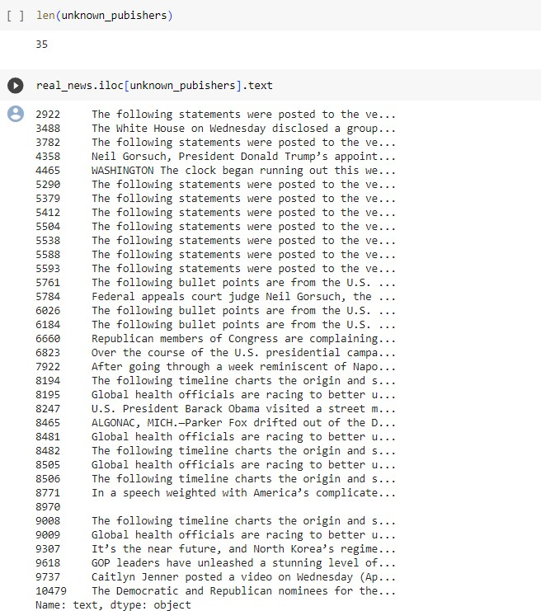

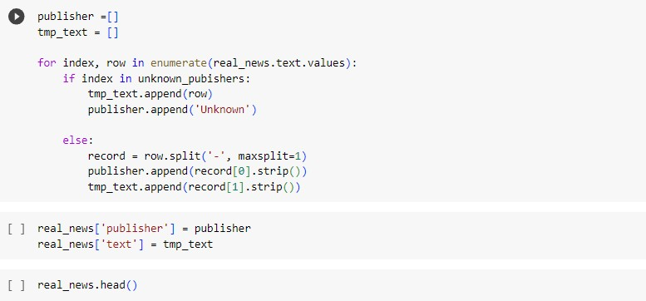

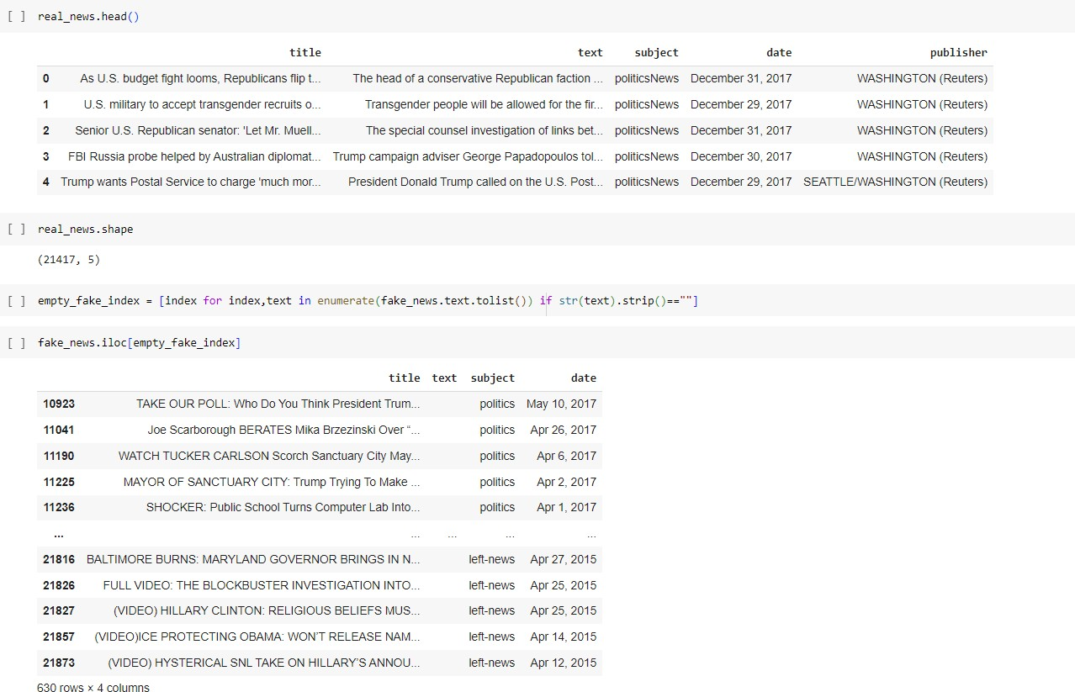

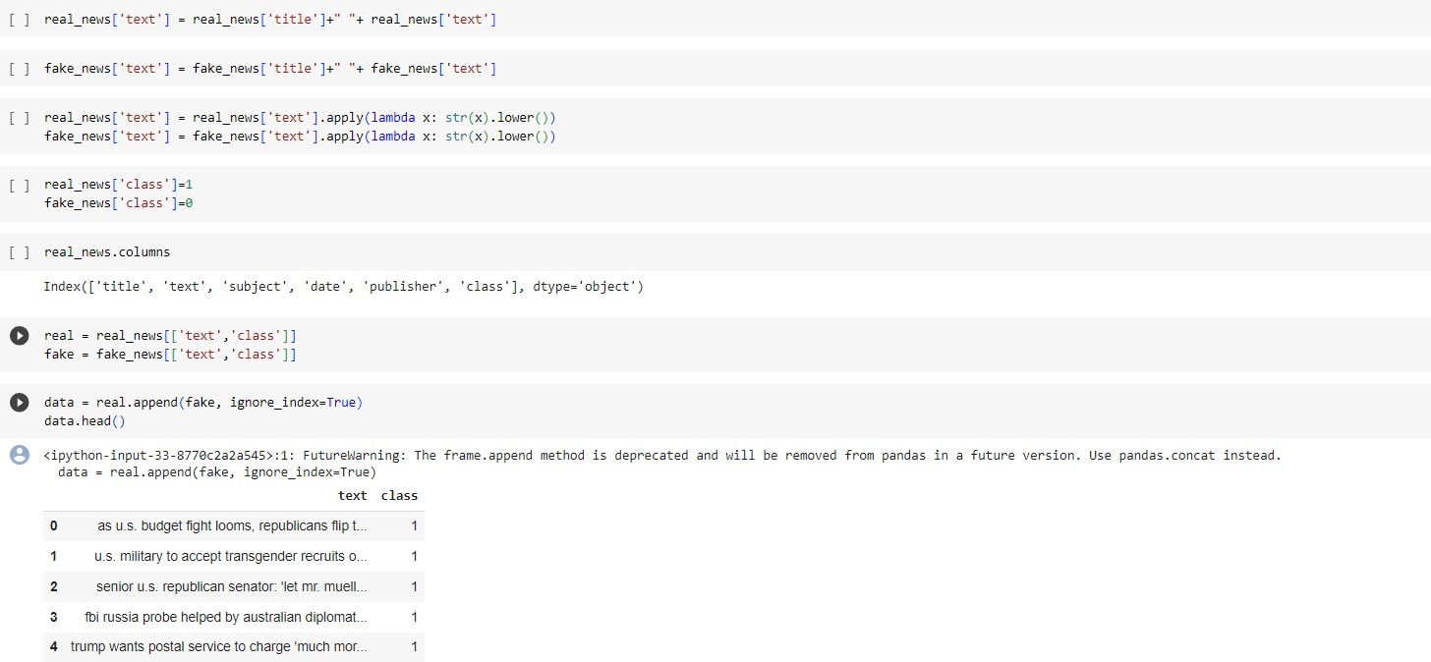

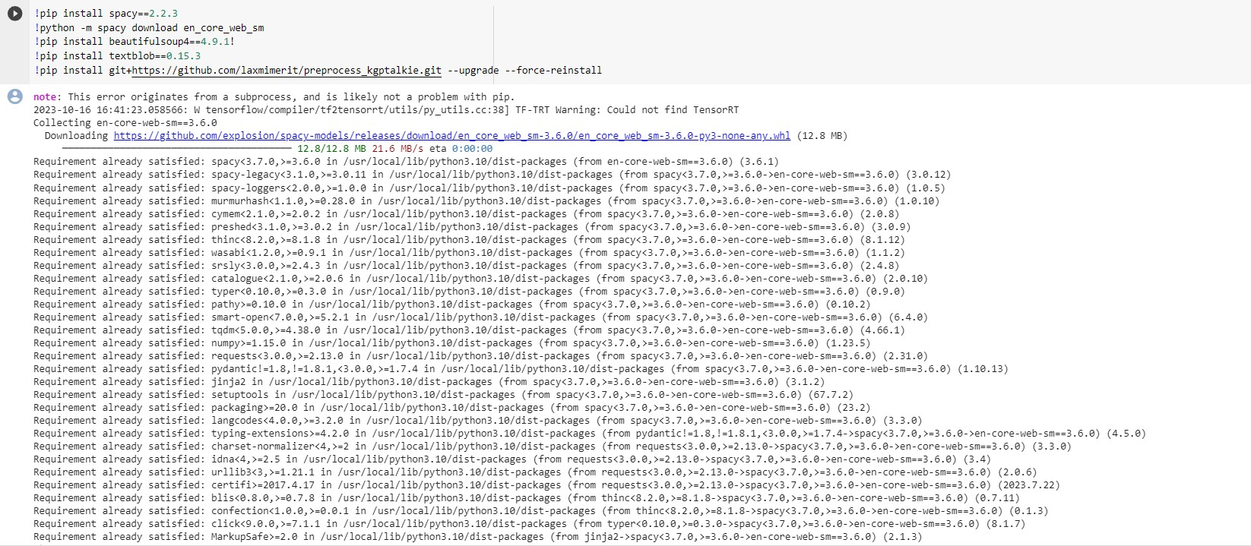

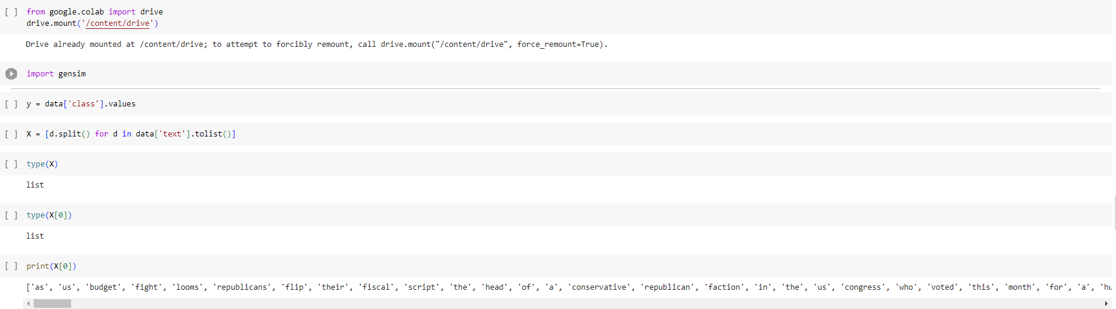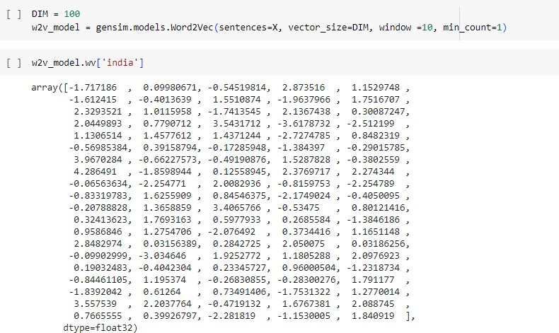

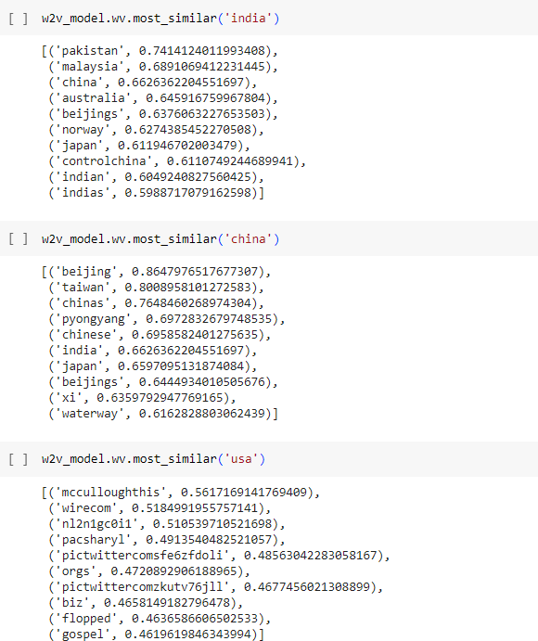

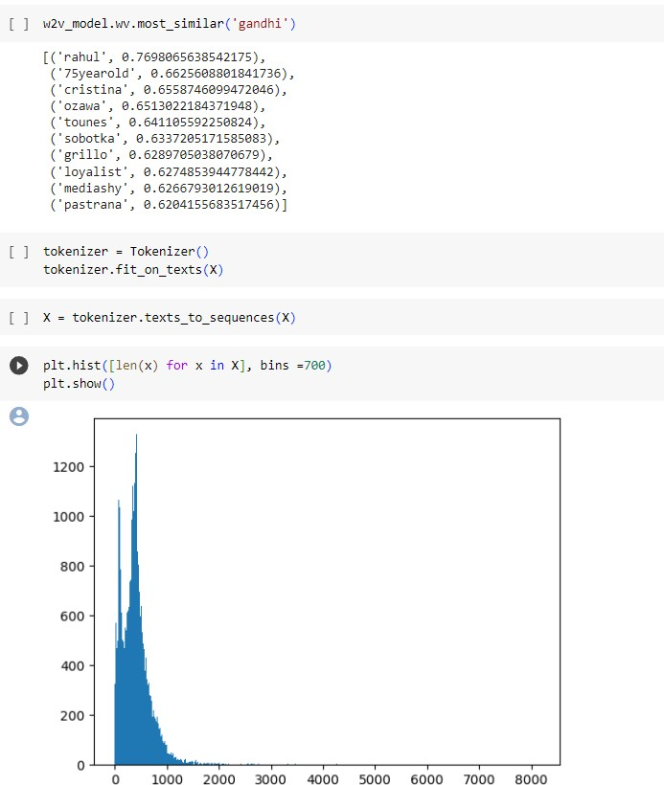

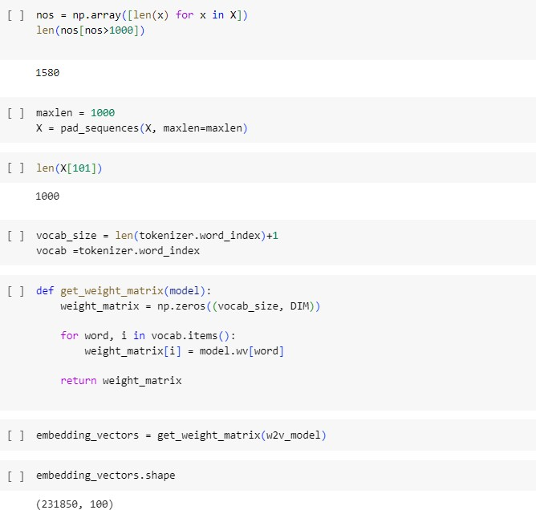

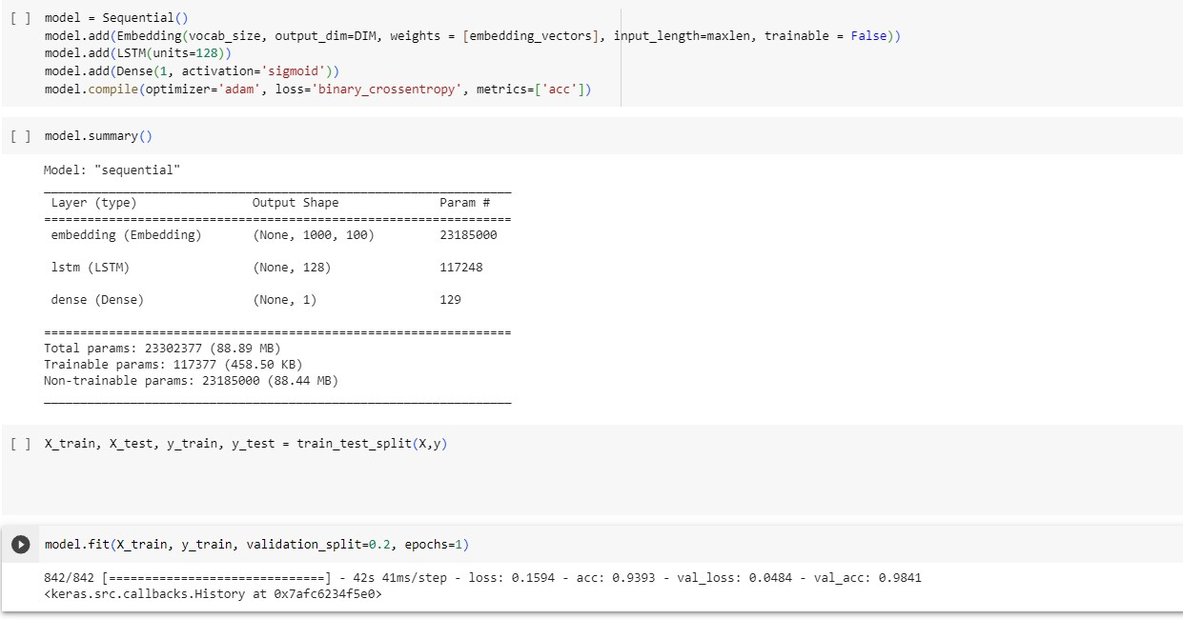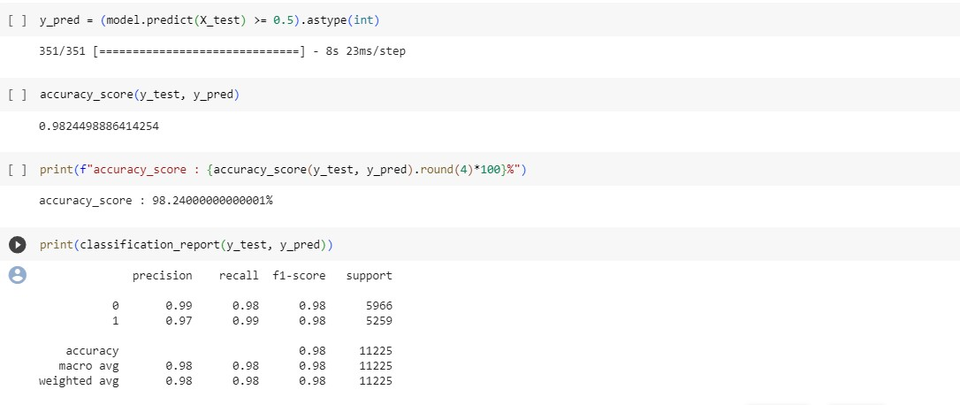

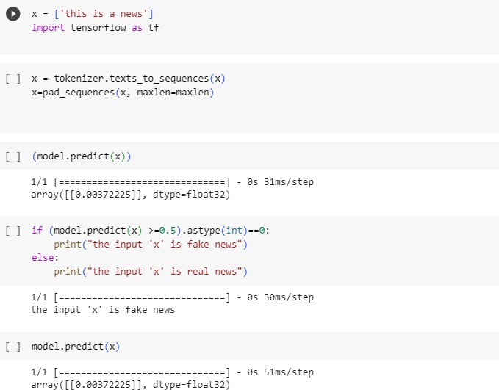

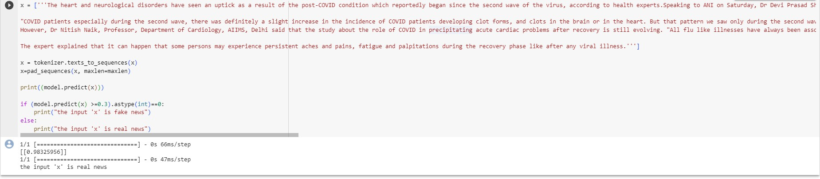

# Conclusion:

Inconclusion,utilizingNaturalLanguageProcessing(NLP)techniquesforfakenewsdetectionhasproventobeasignificantadvancementincombatingmisinformation.Themodeldeveloped

demonstratesthepotentialofmachinelearninginidentifyingdeceptivecontent,contributingtotheongoing efforts to maintain the integrity of information online. By leveraging NLP algorithms, theaccuracy and efficiency of fake news detection have been greatly enhanced, empowering users tomake informed decisions and fostering a more reliable digital information ecosystem. As we moveforward,continuedresearchanddevelopmentinthisfieldwillplayapivotalroleinensuringthe

authenticityandtrustworthinessofonlinecontent,therebypromotingahealthierandmoreinformedsociety.

